1. Get started

Install vue cli:

Npm I -g @vue/cli @vue/cli-service-global

>> -g means globally

>> @vue/cli-service-global for zero configuration option development

\*Zero configuration option demo: (直接在terminal 中實作vue)

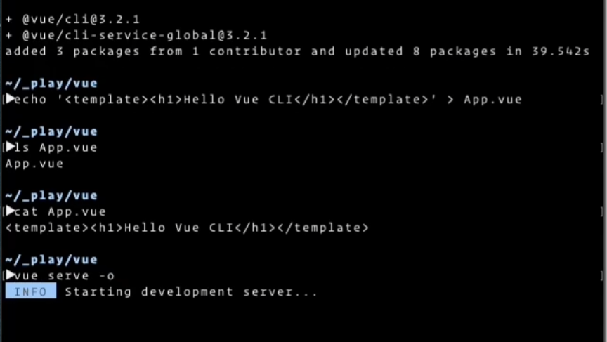

1. Echo html template之後 > App.vue 傳給你的proj
2. Cat 實作
3. 再用vue serve -o (o for “open”)

Why using Vue cli?

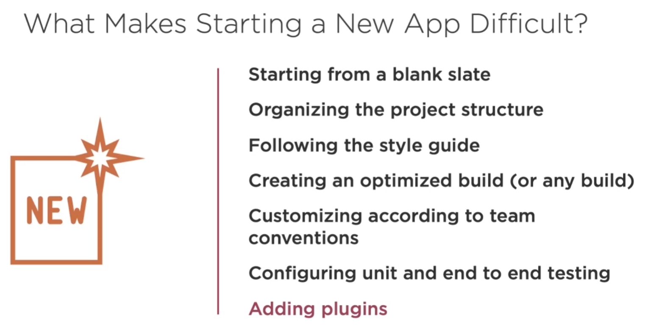

Basic steps to create a proj

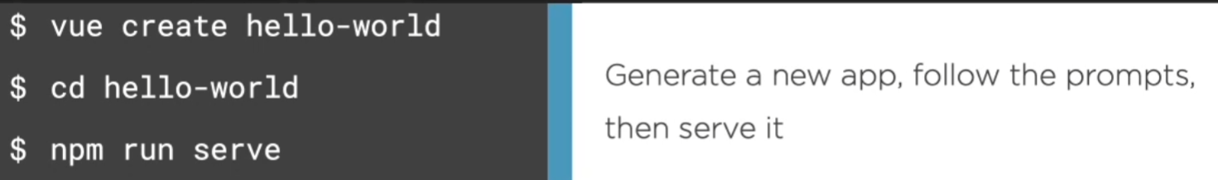

Other commands:

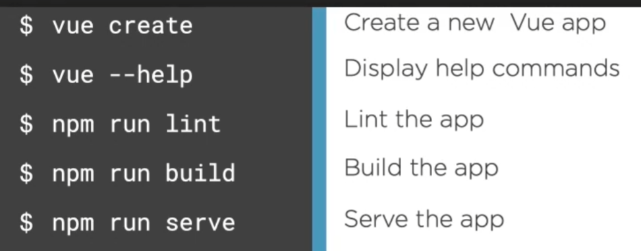

>> Lint: 偵錯

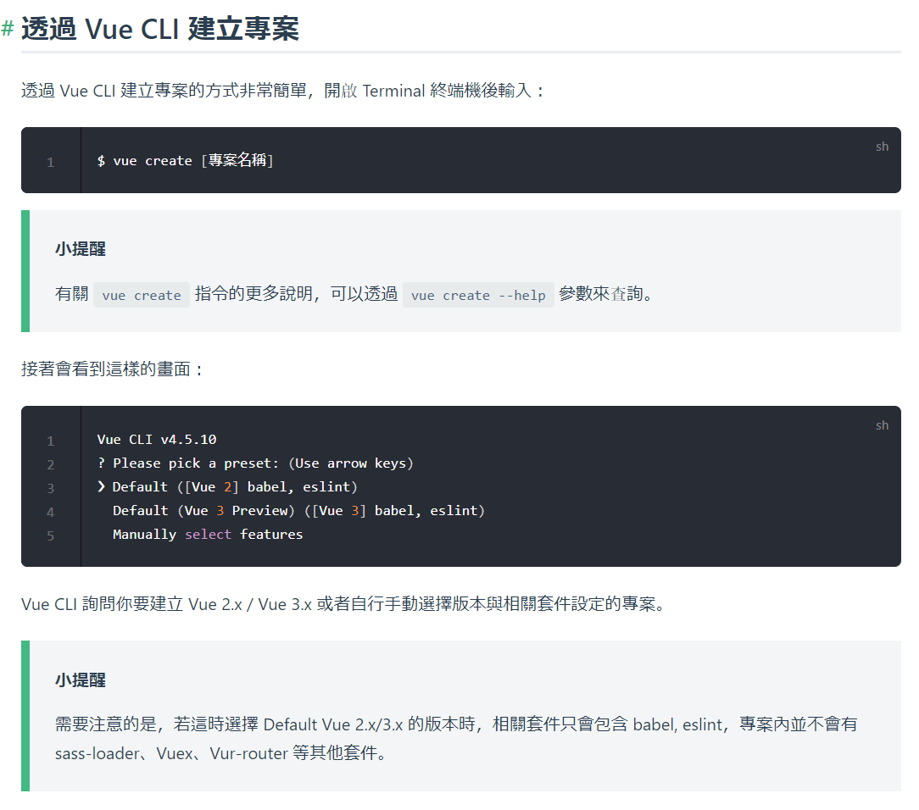

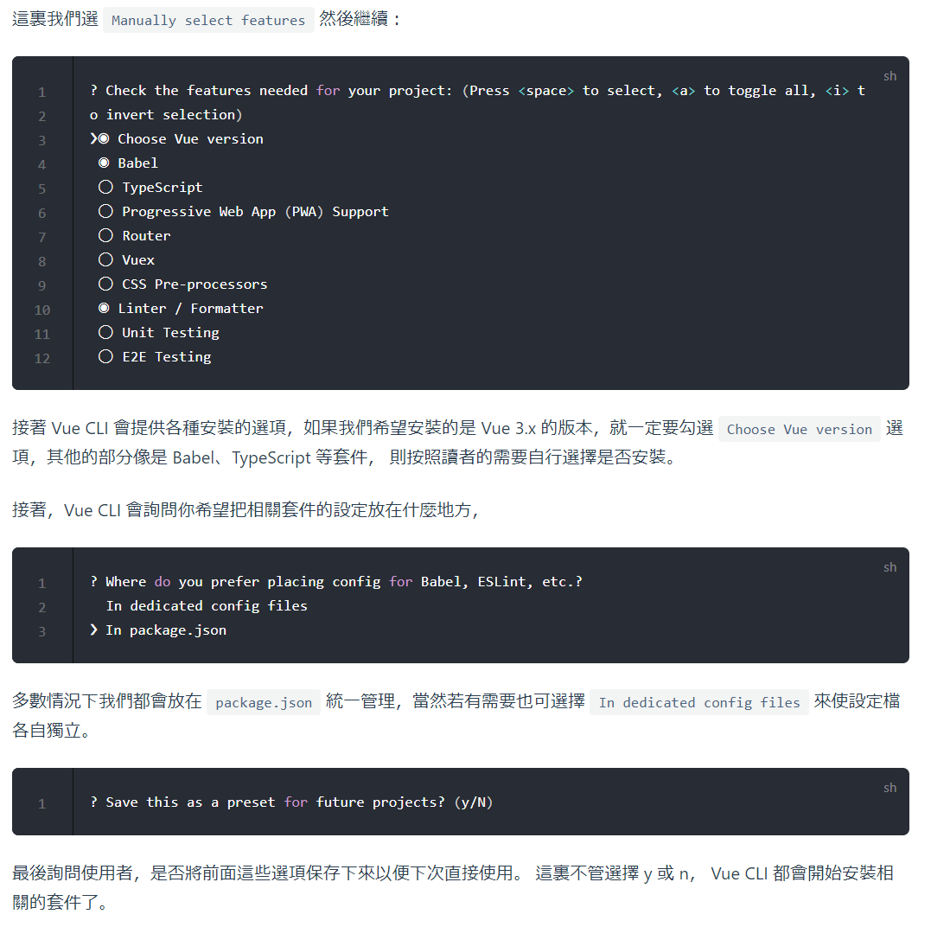

Doing three thins every time

1. Npm run serve to test debug
2. Npm run lint to check block or other errors (by default using eslint)
3. Npm run build when your app is ready to be put on a server (by default doing production build)

>> production build is going to optimize the build for production server

Serve on net:

Npx http-server (like run python server)

* Use vue ui >> vue ui